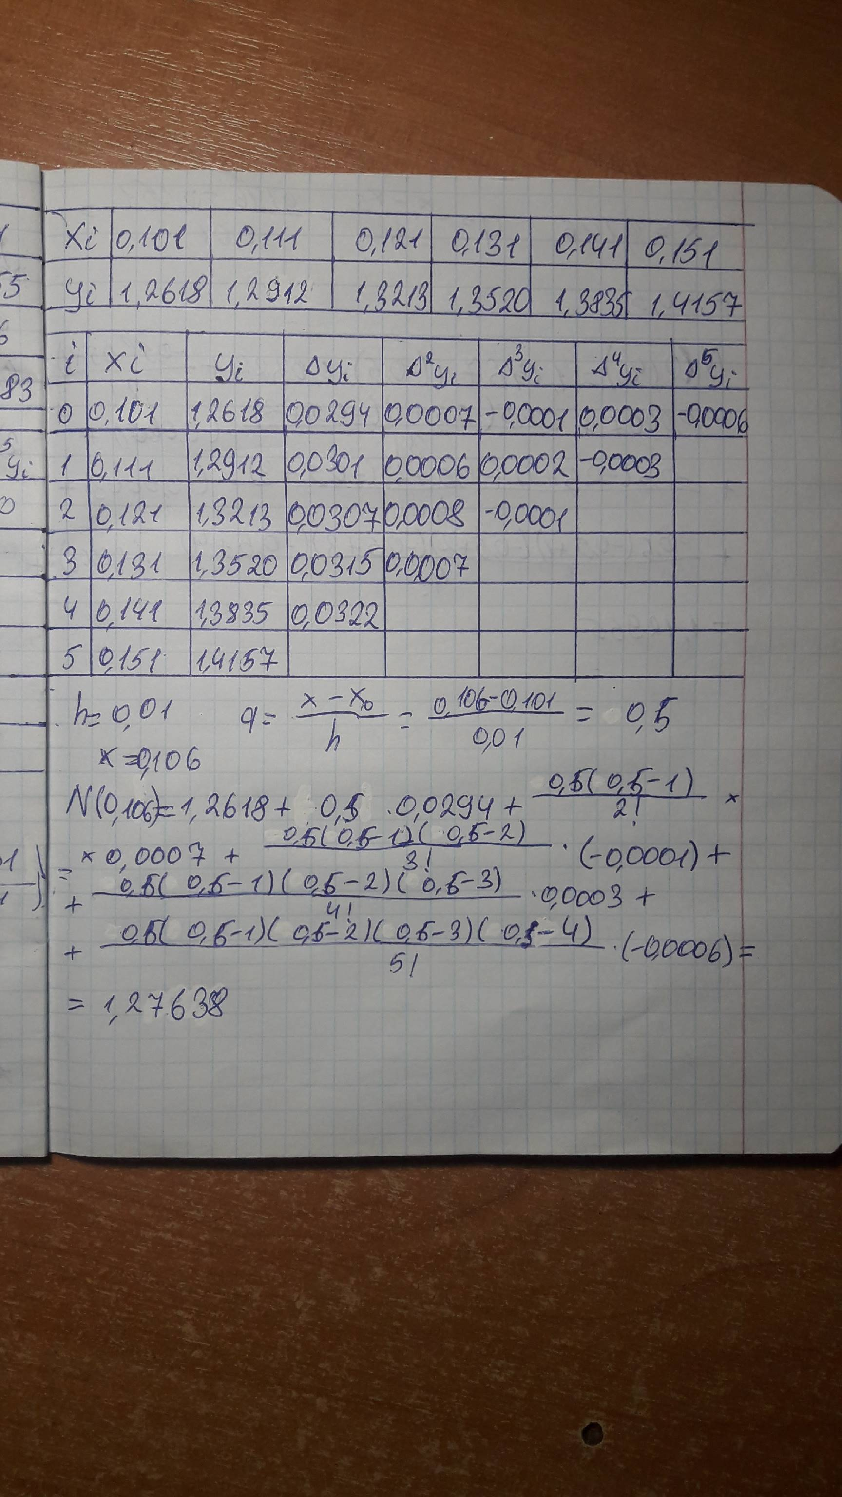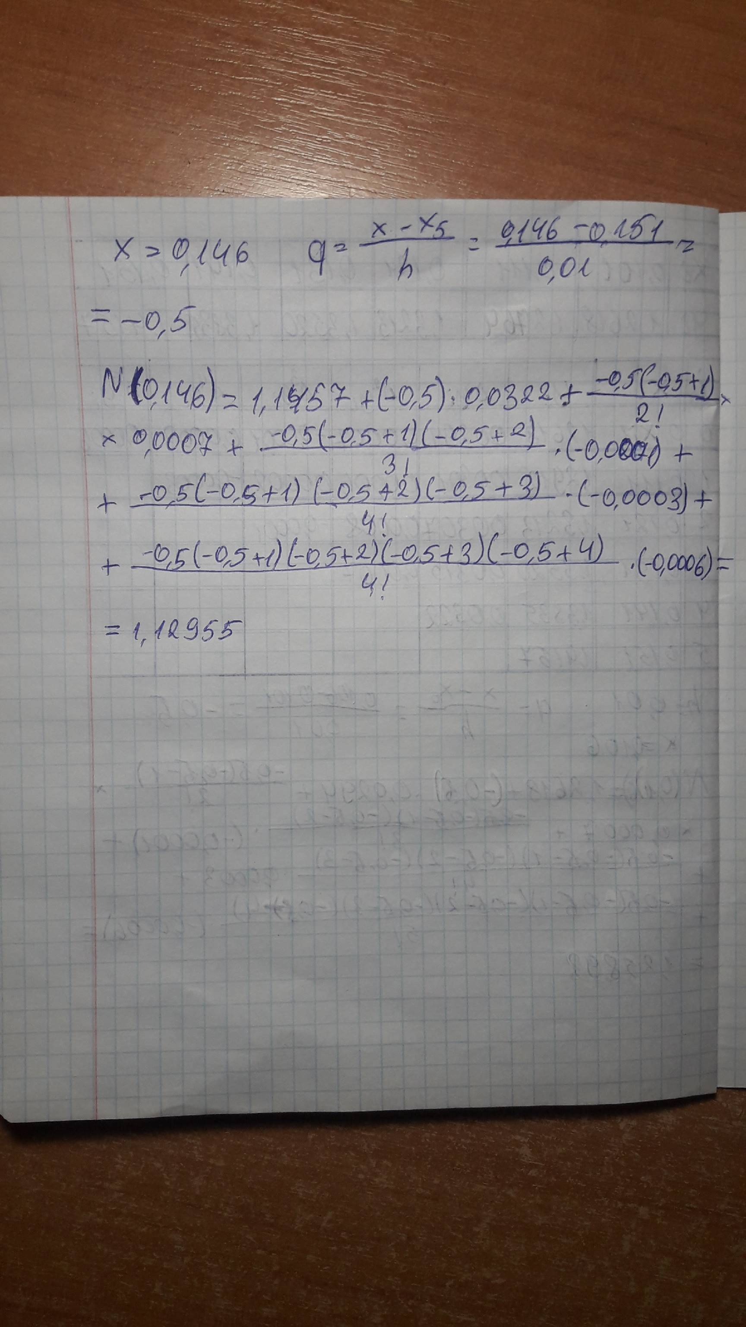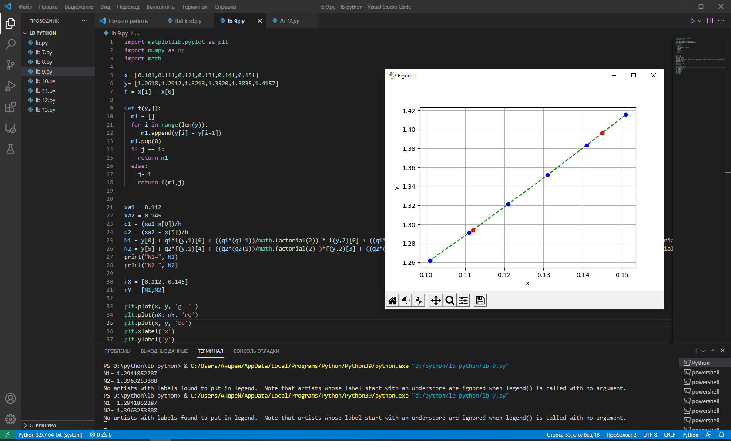

import matplotlib.pyplot as plt

import numpy as np

import math

x= [0.101,0.111,0.121,0.131,0.141,0.151]

y= [1.2618,1.2912,1.3213,1.3520,1.3835,1.4157]

h = x[1] - x[0]

def f(y,j):

  m1 = []

  for i in range(len(y)):

     m1.append(y[i] - y[i-1])

  m1.pop(0)

  if j == 1:

    return m1

  else:

    j-=1

    return f(m1,j)

xa1 = 0.112

xa2 = 0.145

q1 = (xa1-x[0])/h

q2 = (xa2 - x[5])/h

N1 = y[0] + q1\*f(y,1)[0] + ((q1\*(q1-1))/math.factorial(2)) \* f(y,2)[0] + ((q1\*(q1-1)\*(q1-2))/math.factorial(3))\*f(y,3)[0] + ((q1\*(q1-1)\*(q1-2)\*(q1-3))/math.factorial(4)) \* f(y,4)[0] + ((q1\*(q1-1)\*(q1-2)\*(q1-3)\*(q1-4))/math.factorial(5)) \* f(y,5)[0]

N2 = y[5] + q2\*f(y,1)[4] + ((q2\*(q2+1))/math.factorial(2) )\*f(y,2)[3] + ((q2\*(q2+1)\*(q2+2))/math.factorial(3))\*f(y,3)[2] + ((q2\*(q2+1)\*(q2+2)\*(q2+3))/math.factorial(4))\*f(y,4)[1] + ((q2\*(q2+1)\*(q2+2)\*(q2+3)\*(q2+4))/math.factorial(5))\*f(y,5)[0]

print("N1=", N1)

print("N2=", N2)

nX = [0.112, 0.145]

nY = [N1,N2]

plt.plot(x, y, 'g--' )

plt.plot(nX, nY, 'ro')

plt.plot(x, y, 'bo')

plt.xlabel('x')

plt.ylabel('y')

plt.title('')

plt.legend()

plt.grid()

plt.show()